Fuse reference architecture

References
Table of Contents
References 2
Overview 4
Purpose 4
Limitations 4
Product description 5
Standalone and Fabric mode 5
Product usage 6
Fuse as an ESB 6
Fuse and messaging 6
Fuse components 7
Fabric registries 7
ActiveMQ brokers 7
HTTP Gateways 8
MQ Gateways 9
Insight 10
Logical Model 11
Physical Architecture 12
Karaf containers 12
Hosting containers 12
HA and disaster recovery 14
Application high availability 14
Data center disaster recovery 14
Deployment model 15

Overview
This reference architecture has been made to help understand the environment and infrastructure requirements regarding the deployment of Fuse at the customer's.

Purpose
This reference architecture gives a high level overview of the Fuse components and their interactions. Unfortunately there are a lot of possible logical and physical models. It's almost impossible to list all the possibilities in a single document. Instead of describing all those possibilities, this document will rather try to list the mandatory elements of a proper Fuse architecture.

Limitations
The architecture assumes the usage of Fuse v6.2.
Fuse is a very powerful product on which tons of different kinds of applications can be implemented. This reference architecture describes some of the most common use case scenario in a simplified manner. So the specific customer use cases must be taken into consideration and carefully reviewed so that the appropriate modifications can be made on the presented architecture.

Product description
To simplify, Fuse is a wrapper name for a product that groups 3 technologies together:
- CXF : an implementation of the main web services specifications (Soap and Rest)
- Camel: a integration platform technology
- ActiveMQ : an enterprise messaging server
By itself, the product does not implement any application logic. The application logic would come from the development of Camel routes and CXF objects.

Standalone and Fabric mode
Fuse is based on an OSGI runtime (not a JEE runtime) which is based on Apache Karaf.
There are 2 modes in which Fuse can be used:
- Standalone mode
At a high level, the concept is quite similar to EAP 6 in standalone mode.
With Fuse in standalone mode, each Fuse install will consist in a single Karaf container. Of course there can be several install of Fuse on different hosts to provide applications high availability. However, in such a case, each install will have its own management console and the deployments will have to be done in each instances separately.
There is also a possibility to have active/passive instances of Fuse standalone, provided that the instances shared a filesystem.
- Fabric mode
Fabric is a Karaf containers management framework and can be seen as the 4th technology used under the name “Fuse”. Fabric provides something quite similar to the domain mode of Jboss EAP 6. Fabric provides a single location from which all the karaf containers (local and remote) can be managed and from where the applications can be deployed. Therefore there is a single Fuse management console for the whole Fuse infrastructure.
Fabric makes use of a slightly different deployment model (based on versioned “profiles” that wrap Karaf features). It might require a bit of re factoring to be able to deploy the same application on a standalone and on a Fabric instance so it's not recommended to mix standalone and Fabric mode between environments

Product usage

Fuse as an ESB
Fuse is sometimes sold as an ESB technology.
However, it's important to remember that Fuse does not provide:
- any web services registry (except for the URLs stored in zookeeper)
- any web service repository
- any access control or security interception
- any data persistence

Fuse and messaging
Fuse is usually used to expose logic as “services” and in the majority of the cases client applications are not allowed to write directly in the internal activeMQ queues.
As a messaging framework has to be highly available, it's recommended to keep the activeMQ broker containers on separate hosts which are not exposed to the clients when possible.

Fuse components
This reference architecture makes use of the following Fuse components:

Fabric registries
The registries are used by Fabric. They are therefore not part of standalone installs.
Fabric stores information about the containers it manages in a registry (Zookeeper registry).
The registry is needed for:
- management purposes (operations, deployment, web console...)
- the activeMQ discovery protocol
- the HTTP and MQ gateways
The zookeeper registry can be clustered for high availability purposes, but it's important to note that the zookeeper technology is built with quorum capabilities to avoid split-brain scenario.
This means that the registries are accessible only if more than have of the instances are present. The registries cut themselves off if the quorum is not satisfied. Therefore it is absolutely mandatory to have an odd number of registries (1, 3, 5…) in the deployment, particularly if the activeMQ discovery or gateway technologies are in use.

ActiveMQ brokers
For high availability, each activeMQ broker container should be present in a master/slave configuration. Usually the preferred model implies having the master and slave brokers on different hosts. To not loose any message, the slave broker must have access to the data held by the master broker when it becomes the master itself. This can be done in 3 ways:
- Network replication (levelDB)
- Shared filesystem (kahaDB)
- Remote database

HTTP Gateways
HTTP gateways are part of Fabric.
It's a very nice feature that unfortunately is still a tech preview.
The HTTP gateway is an application that can be deployed on any Karaf container to provide dynamic scalability and discovery for web services.
This however works only for CXF-based endpoints.
Each time a CXF endpoint is deployed on a container, the URL of the endpoint is registered in zookeeper, with the URI path as the key. The HTTP gateway relies on this information from zookeeper to load-balance the requests over the registered URLs.
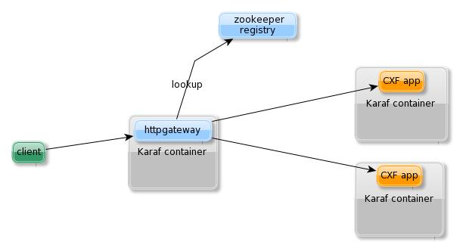
The HTTP gateways is an application that act as a L7 load-balancer. For high availability, it's recommended to use a device L3 load balancer in front to load balance calls over the HTTP gateways.
Also, due to the fact that it interacts directly with clients applications, the HTTP gateways are generally put on dedicated containers (and hosts if possible).

MQ Gateways
The MQ gateway provides a functionality similar to the HTTP gateway one. It offers a single point of access and abstracts the physical location of a message queue in a network of brokers.
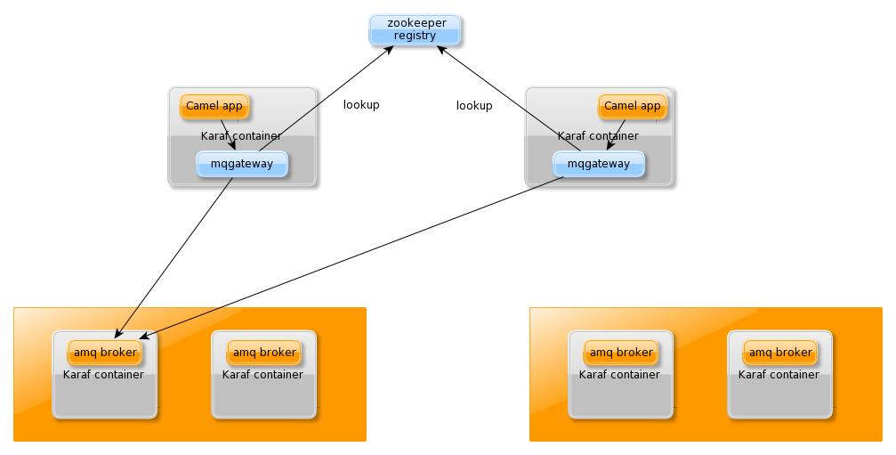
Contrary to the HTTP gateway which is directly called by client applications, the MQ gateway is usually only used internally by the camel components. Therefore there is generally no need to have this component deployed on a dedicated container. Instead the gateway would be collocated with the application.

Insight
Insight is a Fabric component that provides the centralization of some monitoring information provided by the containers. Monitoring information mainly are:
- Logs from all the containers
- Metrics from Camel routes
The technology is based on an embeddable version of the ELK implementation.
The visualization (kibana console) is integration into the Fuse management console.
The component provides good performance by itself, so usually only one (dedicated if possible) container is enough in the infrastructure.
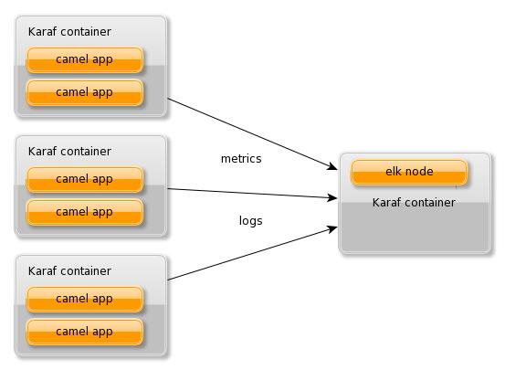

Logical Model
Here is a simplified version of a logical deployment diagram that comes from LGI (June 2015, Schiphol, The Netherlands).
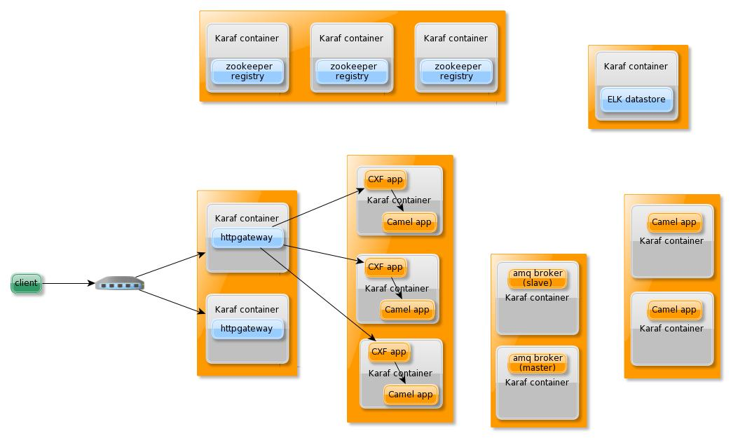
This deployment consists in:
- 3 registries, with each registry on a dedicated container
- 2 Karaf containers used as HTTP gateways, behind a network L3 load balancer
- a set of Karaf containers for the synchronous applications (CXF and Camel)
- a set of Karaf containers for the asynchronous applications
- active/passive MQ brokers
- one Karaf container for the Insigh feature
At LGI, the monitoring of the applications was ensured by Nagios, which made use of custom scripting to extract health information from Fuse through the JMX URL.
STC, on the other hand, relied on Jboss Operations Network and the Fuse plugin pack to monitor their applications.

Physical Architecture

Karaf containers
Karaf has the notion of child containers that allows having more than one container on the same host.
Those containers are defined as sub process of the main Karaf container.
Fabric extends this notion to SSH containers, which are full Karaf containers that can be created either locally or remotely. Each of those could have their own child containers.

There is no golden rule in using one or the other type of container. However we usually stick to the Fabric features and create SSH containers. The only inconvenient of SSH containers is a slight waste of space on the filesystem. Child containers can still be used for the auto-scaler feature, as they are much quicker to be brought online.

Hosting containers
There is no limit in the number of SSH containers that can be deployed on a virtual (or physical) host. The only limitation is the amount of disk space required to install a container (2G per container) and available RAM memory (from 1 to 4G per container, depending on the applications, workload…) and CPU to run the container.
For a production environment it's good to start with 3 virtual or physical machines to minimize the risk of an hardware failure on the availability of the zookeeper registries.
Additional virtual machines can be used to lower the risk of hardware failure on the other components but there is no golden rules to drive those decision.
Ideally a complete production Fabric would start with 7 VMs:
- 3 VM for the zookeeper registries (also hosting Insight datastore...)
- 2 dedicated VMs for the activeMQ brokers and asynchronous applications (if there are)
- 2 dedicated VMs for the HTTP gateways and synchronous applications
But of course some components can still be grouped together on the same VM to reduce this number. For example the asynchronous and synchronous bundles can be both on the same virtual host.

Here is an example of a physical architecture of 7 VMs
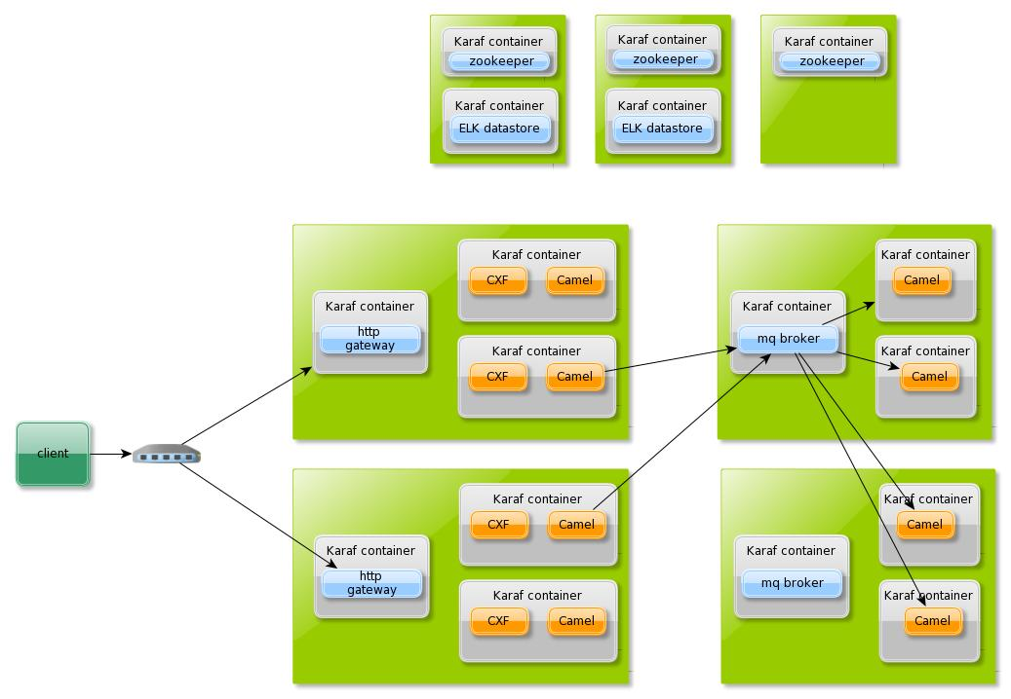
And an equivalent one with only 5 VMs
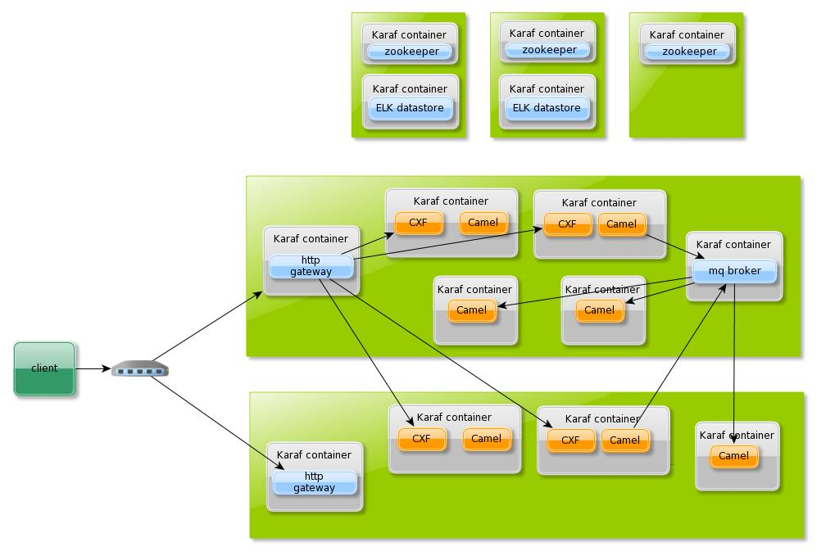

HA and disaster recovery

Application high availability
The developed bundled applications must be deployed on a Karaf container to be run.
There is no limit in the number of applications that can be deployed on the same container, if not the amount of available java heap memory. The principle is similar to the one that drives the number of containers by host.
Having several containers to run an application will guarantee its high availability.
In the same way, the zookeeper registry can be made highly available with multiple copies of them. The only difference is that an odd number of instances is required for that component.

Data center disaster recovery
3 data centers (with inter connectivity) are needed to ensure the high availability of the zookeeper registries.
As the technology is built to prevent split-brain issues, it's totally impossible to ensure recovery in case of the crash of a data center with only 2 data center.
The only way to provide such a capability is to use 2 Fabrics, one for each data center. The model can be active/passive or active/active. In both case the availability is controlled by a network redirection (either DNS or load balance-based).
The drawback is that the deployment/operations will have to be done twice but however, on the other hand, the model would fit a Blue/Green deployment model.

Deployment model
The most difficult part to handle with Fuse is perhaps the OSGI framework and deployment model.
First because an OSGI framework is a bit different from a JEE framework, and second because there is no proper tooling to deploy applications on Fuse. The only possibilities are:
- using the fuse management console
- using the maven fabric8 plugin (requires deploying from the source code)
- using custom scripts on the command line

On a Karaf container only OSGI bundles can be deployed. OSGI bundles are jar files with additional META-DATA information used for dependency management but it's not always easy to manage those META-DATA by hand. For the development of applications we recommend the usage of maven which has a plugin to automatically manage those META-DATA.
Deploying one or more bundles on Fuse means making Fuse aware of the location of those bundles. The location could be a directory on the filesystem. However it's also possible to use maven coordinates. So for the deployment of artifacts we recommend the usage of an external maven repository that must be accessible by Fuse.

